

Special Educational Needs Policy



This policy was approved as follows
MAC Board of Trustees Date: January 2025
Frequency of review:
Unless there are legislative or regulatory changes in the interim, this policy will be reviewed every two years. Should no substantive changes be required at that point, the policy will move to the next review cycle

Related documents:
- Equality and Diversity Policy
- Child Protection and Safeguarding Policy
- Mental Health and Wellbeing Policy
- Curriculum Policy (especially PSHE)
- Complaints Policy
- Whistleblowing Policy
- Staff Code of Conduct
- Anti-bullying & behaviour policy

Summary of policy:
This policy outlines how OLAAS Academies will work to promote inclusive practice through high quality first teaching, evidence driven interventions and equality access for all.

Academy SEND Lead is: | Mrs Marie Conway- School Improvement Lead

OLAAS Mission Statement:
To secure positive outcomes for all of our pupils, including the disadvantaged and those with special educational needs or disabilities, by providing an exciting, broad and balanced curriculum, delivering high quality teaching and learning and providing an outstanding range of opportunities and experiences.

St Edward’s Catholic Primary School and Nursery
Packington Lane, Coleshill, B46 3JE
Tel: 01675 437 539
https://www.stedwardsrcprimary.co.uk/
Email: admin3503@welearn365.com
Executive Headteacher: Mrs Flanagan
Head of School: Mr Carroll
Assistant Headteachers: Mrs Conway and Mr Phillips
SENCo: Mrs Conway

Our Lady and All Saints (OLAAS) Special Educational Needs and Disability (SEND) Policy
OLAAS MAC Strategy and Mission:
Directors, governors and MAC school leaders are committed to provide a flourishing Catholic culture in all its schools that is motivating and ambitious for all and rooted in Catholic Social Teaching. This includes disadvantaged and marginalised children and children with SEND. OLAAS MACs strategy focusses on provide a flourishing, fully-inclusive education, especially for the disadvantaged and which makes Christ known to all people. Each school does this through teaching that is adaptive and responsive, all teachers feel confident to teach all pupils. All OLAAS MAC schools welcomes and effectively teaches disadvantaged and marginalised children and children with SEND from their local areas. The MAC is committed to supporting pupils and schools to address issues so pupils can be educated in the most appropriate setting, staying in or rejoining mainstream school where possible.
Across OLAAS MAC all schools are expected to provide appropriate support for those children with special educational needs and disabilities (SEND) who attend their schools. At each of our schools we support all children to achieve well throughout their school life.
Every pupil with SEN and disability in our schools has an entitlement to fulfil his/her potential. This is achieved by ensuring the health and well-being of all pupils as well as supporting them to make academic progress. We work in partnership with parents and carers, across schools, the local community and external support services and providers.
These outcomes are embraced in every aspect of school life; personalised teaching and learning approaches; access to technology across the curriculum; flexible learning pathways and out of hours learning activities; support for emotional well-being; flexible timetables; assessment systems that engage pupils in having a say about their progress and additional provision.
This special educational needs policy should read in conjunction with our school’s Information report. This policy will be reviewed at least bi-annually and was ratified by the Board of directors..

Our specific aims and aspirations for children with special educational needs are:
- To be aware of and respond to God’s presence in our Community in accordance with the ideals of the Catholic Faith.
- To reflect that presence as we strive to share the love, security, warmth, acceptance and trust necessary for each member of our Community to grow.
- To create a calm and positive environment where everyone feels valued and respected.
- To enable each child to achieve the highest possible standard of work and behaviour in relation to their age, ability and prior attainment.
- To provide the children with a Broad and Balanced Curriculum where Teaching and Learning is of the highest quality which meets their needs and the requirements of the National Curriculum.
- In particular to provide children with a strong grounding in R.E and also the key skills in Language (reading, writing, speaking and listening) and Mathematics.
- To encourage the children’s participation in their own development by recognising their views and wishes through consultation.
- To provide for the Professional Development of all staff in meeting the needs of the individual and the school.

INTRODUCTION

Catholic Mission Statement
Each School’s Mission underpins all aspects of the SEND policy.

Our School Mission Statement which underpins our ethos and vision:
We carry the light of Christ as we love, live, learn and look after each other

We value the individuality of all our children and are committed to giving all of them every opportunity to reach their potential. Through providing this firm foundation of a Catholic Ethos, based on the teachings of the Catholic Church, we seek to lead our children to a living and active faith. This will help them all to acquire skills and knowledge enabling them to participate fully and confidently in all aspects of school and community life.

SPECIAL EDUCATIONAL NEEDS

Aims of this SEND policy
The aims of our special educational needs and disability policy and practice in this MAC are:-
- To ensure that children and young people with SEND engage in the full range of activities offered by the school alongside pupils who do not have SEND.
- To make reasonable adjustments for those with a disability by taking action to increase access to the curriculum and the environment
- To make every effort to secure special educational provision for pupils for whom this is required, that is “additional to and different from” that provided within the differentiated curriculum.
- To ensure a high level of staff expertise to meet pupil need, through well-targeted continuing professional development.
- To work in partnership with the Local Authority and outside agencies included health professionals.
- To work in partnership with parents/carers and children in order to help them to be the best they can be.

What are special educational needs (SEN) or a disability?
We use the definition for SEN and for disability from the SEND Code of Practice (2014). This states:-
“SEN: A child or young person has special educational needs if he or she has a learning difficulty or a disability which calls for special educational provision to be made for him or her. A learning difficulty or disability is a significantly greater difficulty in learning than the majority of others of the same age. Special educational provision means educational or training provision that is additional to, or different from, that made generally for others of the same age in a mainstream setting in England.
Disability: Many children and young people who have SEN may have a disability under the Equality Act 2010 – that is ‘…a physical or mental impairment which has a long-term and substantial adverse effect on their ability to carry out normal day to day activities.’ This definition includes sensory impairments such as those affecting sight or hearing and long-term health conditions such as asthma, diabetes, epilepsy and cancer.
(https://www.gov.uk/government/publications/send-code-of-practice-0-to-25)

How do staff know if children have special educational needs and need extra help?
We know children need help if:-
- Concerns are raised by parents/carers, teachers or the child’s previous school or setting, or from information from the Local Authority or outside support agency regarding a child’s level of progress or inclusion.

- A pupil asks for help.

- Observation of the pupil indicates that they have additional needs in one or more of the four broad areas of need as described in the code of practice for SEND:-
- Communication and interaction
- Cognition and learning
- Social, mental and emotional health
- Sensory/physical

- Whole school tracking of outcomes indicates concern about progress or general well-being.

What should a parent do if they think their child may have special educational needs?
If parents have concerns relating to their child’s learning then please discuss these initially with your child’s class teacher, they are the expert in teaching your child. This then may result in a referral by them to the school’s SENCO, whose contact details are Conway.j@welearn365.com
Parents may also contact a member of the Senior Leadership team directly if they feel this is more appropriate.
All parents will be listened to. Their views and their aspirations for their child will be central to the assessment and provision that is provided by the school.

The kinds of special educational needs for which provision is made.
Children and young people with SEN have different needs, but all children with SEND are welcomed at our schools, in line with individual school’s admissions policy. If a place is available, we will undertake to use our best endeavours, in partnership with parents, to make the provision required to meet the SEND of pupils at this school.

For children with an Education, Health and Care Plan (EHCP), parents have the right to request a particular school and the Local Authority must comply with that preference and name of the school or college in the Education, Health and Care Plan unless:-
- it would be unsuitable for the age, ability, aptitude or SEN of the child or young person, or
- the attendance of the child or young person there would be incompatible with the efficient education of others, or the efficient use of resources.

Before making the decision to name a school in a child’s EHCP, the Local Authority will send the governing body a copy of the EHCP and then consider their comments very carefully before a final decision on placement is made. In addition, the Local Authority must also seek the agreement of school where the draft EHCP sets out any provision to be delivered on their premises that have been secured through a direct payment (personal budget).
Parents of a child with an EHCP also have the right to seek a place at a special school if they consider that their child’s needs can be better met in specialist provision.
How will the school support a child with SEND?
All pupils will be provided with high quality teaching that is scaffolded to meet the diverse needs of all learners, for a small number of children differentiation will be used to support children to learn.
Pupils with a disability will be provided with reasonable adjustments (such as auxiliary aids and services – see Information Report for more information) to overcome any disadvantage experienced in schools and increase their access to the taught curriculum.
The quality of classroom teaching provided to pupils with SEND is monitored through a number of processes that includes:-
- Classroom observations by the senior leadership team, the SENCo, external verifiers;
- On-going assessment of progress made by pupils with SEND;
- Work sampling and scrutiny of planning to ensure effective matching of work to pupil need;
- Teacher meetings with the SENCo to provide advice and guidance on meeting the needs of pupils with SEND;
- Pupil and parent feedback on the quality and effectiveness of interventions provided;
- Attendance and behaviour records.

All pupils have individual curriculum targets set in line with national outcomes to ensure ambition. Parents are informed of these via the reporting system and also at events such as Parents’ Evenings.
Pupils’ attainments are tracked using the whole school tracking system, overseen by the SLT, and those failing to make expected levels of progress are identified very quickly. Where appropriate, in liaison with the SENCO, provision will be put into place to move the learning on and to close the gap with peers. This information is recorded on a provision map which allows close monitoring of the impact the adjustments to teaching and provision is having.
If we consider at this stage that special educational provision is required, we will contact parents to discuss this.
Action relating to SEN support will follow an assess, plan, do and review model as explained in the SEND Code of Practice (2015):
- Assess: Data on the pupil held by the school will be collated by the class/subject teacher in order to make an accurate assessment of the pupil’s needs. Parents will always be invited to this early discussion to support the identification of action to improve outcomes.
- Plan: If review of the action taken indicates that “additional to and different from” support will be required, then the views of all involved including the parents and the pupil, will be obtained and appropriate evidence-based interventions identified, recorded and implemented by the class/subject teacher with advice from the SENCo.
- Do: SEN support will be recorded on a plan that will identify a clear set of expected outcomes, which will include stretching and relevant academic and developmental targets (this may include for young people targets around preparing for adulthood) that take into account parents’ aspirations for their child. Parents and the pupil will also be consulted on the action they can take to support attainment of the desired outcomes. This will be recorded and a date made for reviewing attainment.
- Review: Progress towards these outcomes will be tracked and reviewed termly with the parents and the pupil.

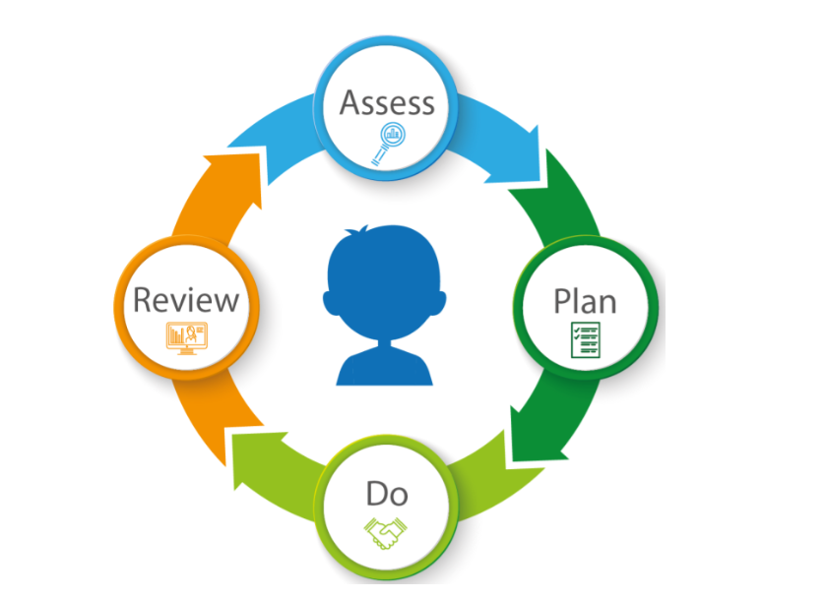

As a result of the review process we may decide to involve outside agencies for specialist support.
The range of agencies that come into school can be found in the school’s local offer (SEN information report).
The school will involve external agencies as appropriate including health and social services, community and voluntary organisations for advice on meeting the needs of pupils with SEND and in further supporting families.
For a very small percentage of pupils, whose needs are significant and complex and the SEN support required to meet their needs cannot be provided from within the school’s own resources, a request will be made to the Local Authority to conduct an assessment of education, health and care needs. This may result in an Education, Health and Care Plan (EHCP) being created.

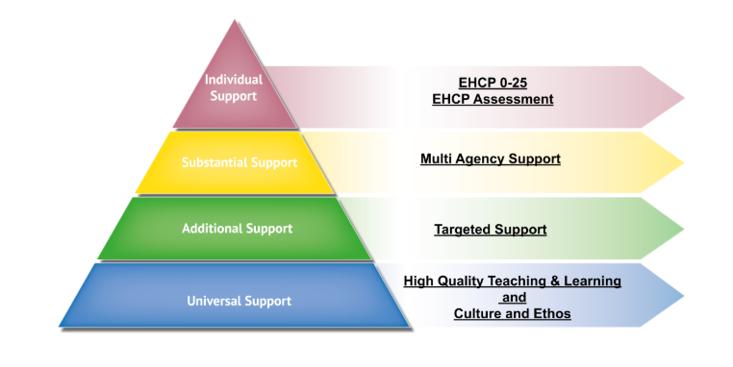

How will the curriculum be matched to each child’s needs?
Teachers plan using pupils’ achievement levels, scaffolding and if necessary differentiating tasks to ensure progress for every pupil in the classroom.
When a pupil has been identified as having special educational needs, the curriculum and the learning environment will be further adapted by the class teacher to reduce barriers to learning and enable them to access the curriculum more easily. High impact, research led interventions may also be delivered to provide opportunities for pre-teaching and consolidation and retrieval practice.
These adaptations may include strategies suggested by the SENCo and/or external specialists.
In addition if it is considered appropriate, pupils may be provided with specialised equipment or resources such as ICT and/or additional adult help. All actions taken by the class teacher will be recorded and shared with parents.

How will parents know how their child is doing?
Where appropriate, children on the SEND register will have an Individual Provision Plan (IPP) or management plan which will be reviewed and updated accordingly at least once a year with the SENCO and class teacher, and a further 2 times a year with the class teacher. The school SENCO has regular progress meetings with class teacher to monitor all SEND children and ensure provision remains appropriate. During these meetings provisions will be evaluated and next steps highlighted. Copies of these will be sent home.
Parents are invited in termly for Parents’ Evening to review their child’s progress with class teacher and in the summer term a report will be sent home.
In certain circumstances a home-school diary can be set up in order to communicate with school staff on a regular basis.
Parents are encouraged to arrange an appointment to discuss their child’s progress with the class teacher in the first instance who will then share with the SENCo and members of the senior leadership team as necessary, at any time when they feel concerned or have information they feel they would like to share that could impact on their child’s success. Please contact the school office who will arrange this appointment for you. The contact number is 0121 7798060.
What support will there be for children’s overall well-being?
The school offers a wide variety of pastoral support for children. These include:-
An evaluated Personal, Social, Health and Economic (PHSE) curriculum that aims to provide pupils with the knowledge, understanding and skills they need to enhance their emotional and social knowledge and well-being.
Pupil and Parent voice mechanisms are in place and are monitored for effectiveness by the Governor for responsibility for this area.
Small group evidence-led interventions to support pupil’s well-being are delivered to targeted pupils and groups. The aim of these groups are to support improved interaction skills, emotional resilience and well-being.
The school has gained Healthy School status which evidences the work undertaken within the school to support pupils’ well-being and mental health.
For information about pupils with medical needs please refer to the Medicines in Schools Policy. https://www.gov.uk/government/publications/mental-health-and-behaviour-in-schools--2
How are the school’s resources allocated and matched to children’s special educational needs?
The school receives funding to respond to the needs of pupils with SEND from a number of sources that includes:-
- A proportion of the funds allocated per pupil to the school to provide for their education called the Age Weighted Pupil Unit.
- The Notional SEN budget. This is a fund devolved to schools to support them to meet the needs of all pupils with SEND.
- The Pupil Premium funding provides additional funding for pupils who are claiming Free School Meals, who are in the care of the Local Authority or whose parents are in the Armed Services.
- For those pupils with the most complex needs, the school may be allocated additional educational needs funding from the Local Authorities High Needs SEN Funding allocation. This funding is then used to provide the equipment and facilities to support pupils with special educational needs and disabilities. The range of support offered is identified on the provision maps which are available to view on the school website. These target the road areas of need:-
- Cognition and learning
- Behavioural, emotional and social
- Communication and interaction
- Sensory and/or physical
If parents wish to discuss the options available for their child, they are welcome to make an appointment to see the class teacher, SENCo or a member of the Senior Leadership Team.
http://www.councilfordisabledchildren.org.uk/media/409191/cdc_funding_briefing_for_parents_-_final.pdf
How is the decision made about how much support each child will receive?
- For pupils with SEN but without an EHCP, the decision regarding the support provided will be in consultation between the Headteacher, the SLT and SENCO. Views of parents will always be taken into consideration.
- For pupils with an EHCP, this decision will be reached during consultation between the headteacher, the SLT and SENCO. Views of parents will always be taken into consideration during Annual Reviews.

- How will I be involved in discussions about and planning for my child’s education?
This will be through:-
- discussions with the class teacher, SENCo or Senior Leadership Team member;
- during parents’ evenings;
- meetings with support and external agencies.
Who can I contact for further information or if I have any concerns?
If you wish to discuss your child’s special educational needs or are unhappy about any issues regarding the school’s response to meeting these needs, please contact the following:-
- Your child’s class teacher;
- The SENCo – Mrs Conway
- Mrs Flanagan
- Mr Carroll
For any complaints, please contact the School Governor with responsibility for SEN who can be contacted via St Edward’s School Office.

Information on where the Local Authority’s that OLAAS serve’s, Local Offer can be found:
Solihull’s Local Offer can be found via this link:-
http://socialsolihull.org.uk/localoffer/
Birmingham’s Local Offer can be found via this link:
https://www.localofferbirmingham.co.uk/
Warwickshire’s Local offer can be found via this link:
https://www.warwickshire.gov.uk/send
Staffordshire’s Local offer can be found via this link:
https://www.staffordshireconnects.info/kb5/staffordshire/directory/localoffer.page?localofferchannel=0
Worcestershire’s Local offer can be found via this link:
https://www.worcestershire.gov.uk/council-services/schools-education-and-learning/send-local-offer

Glossary
(A glossary of terms is included in the appendices of the SEND Code of Practice)
DfE: Department for Education
EHCP: Education, Health and Care Plan
LA: Local Authority
SEN Support: Children who are supported by the Inclusion Team and are on the SEND register.
SEND Register: SIMS list of children who have additional needs or disability.
SEN: Special Educational Needs
SEND: Special Educational Needs and/or Disability
SENCo: Special Educational Needs Coordinator (also written as SENCO)
PPS: Parent Partnership Services

